Twitter Signup and Key CreationCapturing and Analyzing Social Media Data Using Twitter  
Eric Shook  
eshook@umn.edu

# Signup and Make Our First Tweets

Signup for an account by clicking “Sign up”

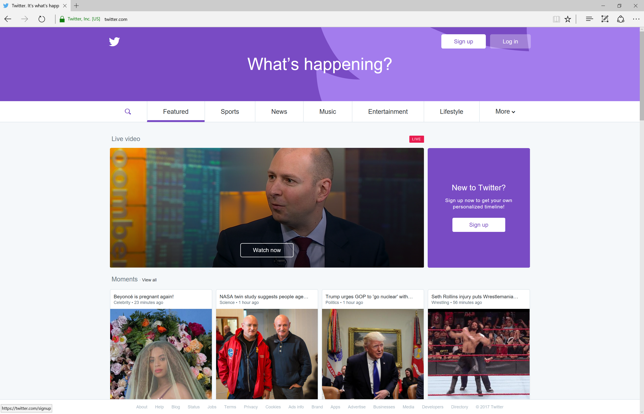

Fill out the information to create your Twitter account.

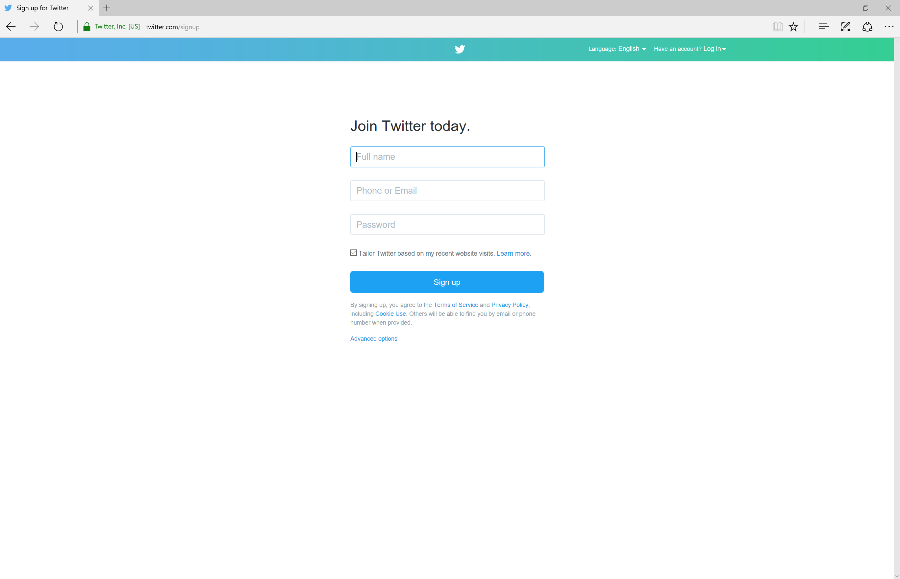

**Important note:** You cannot skip phone verification if you wish to capture tweets today.

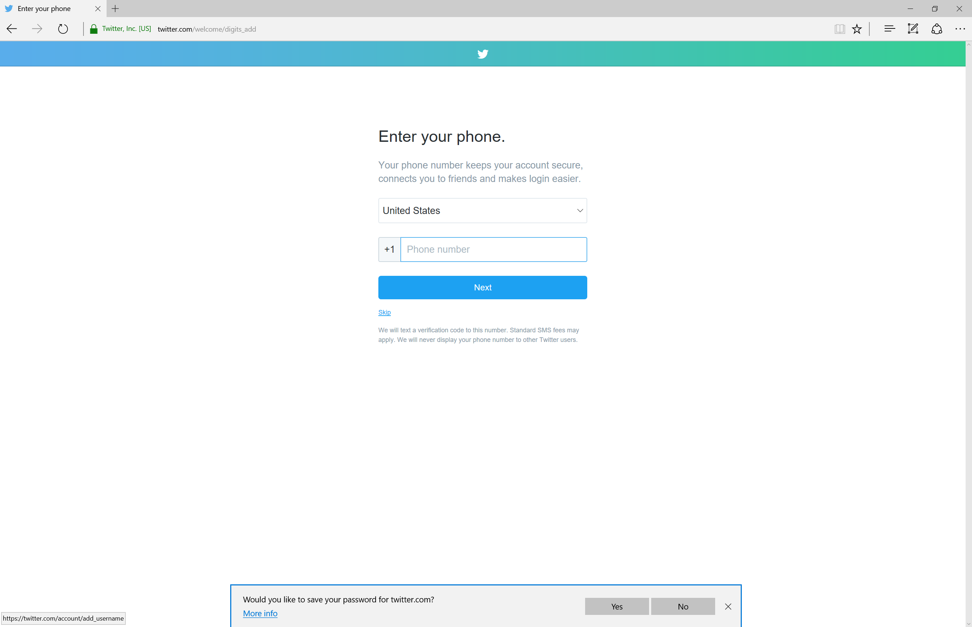

Pick a username

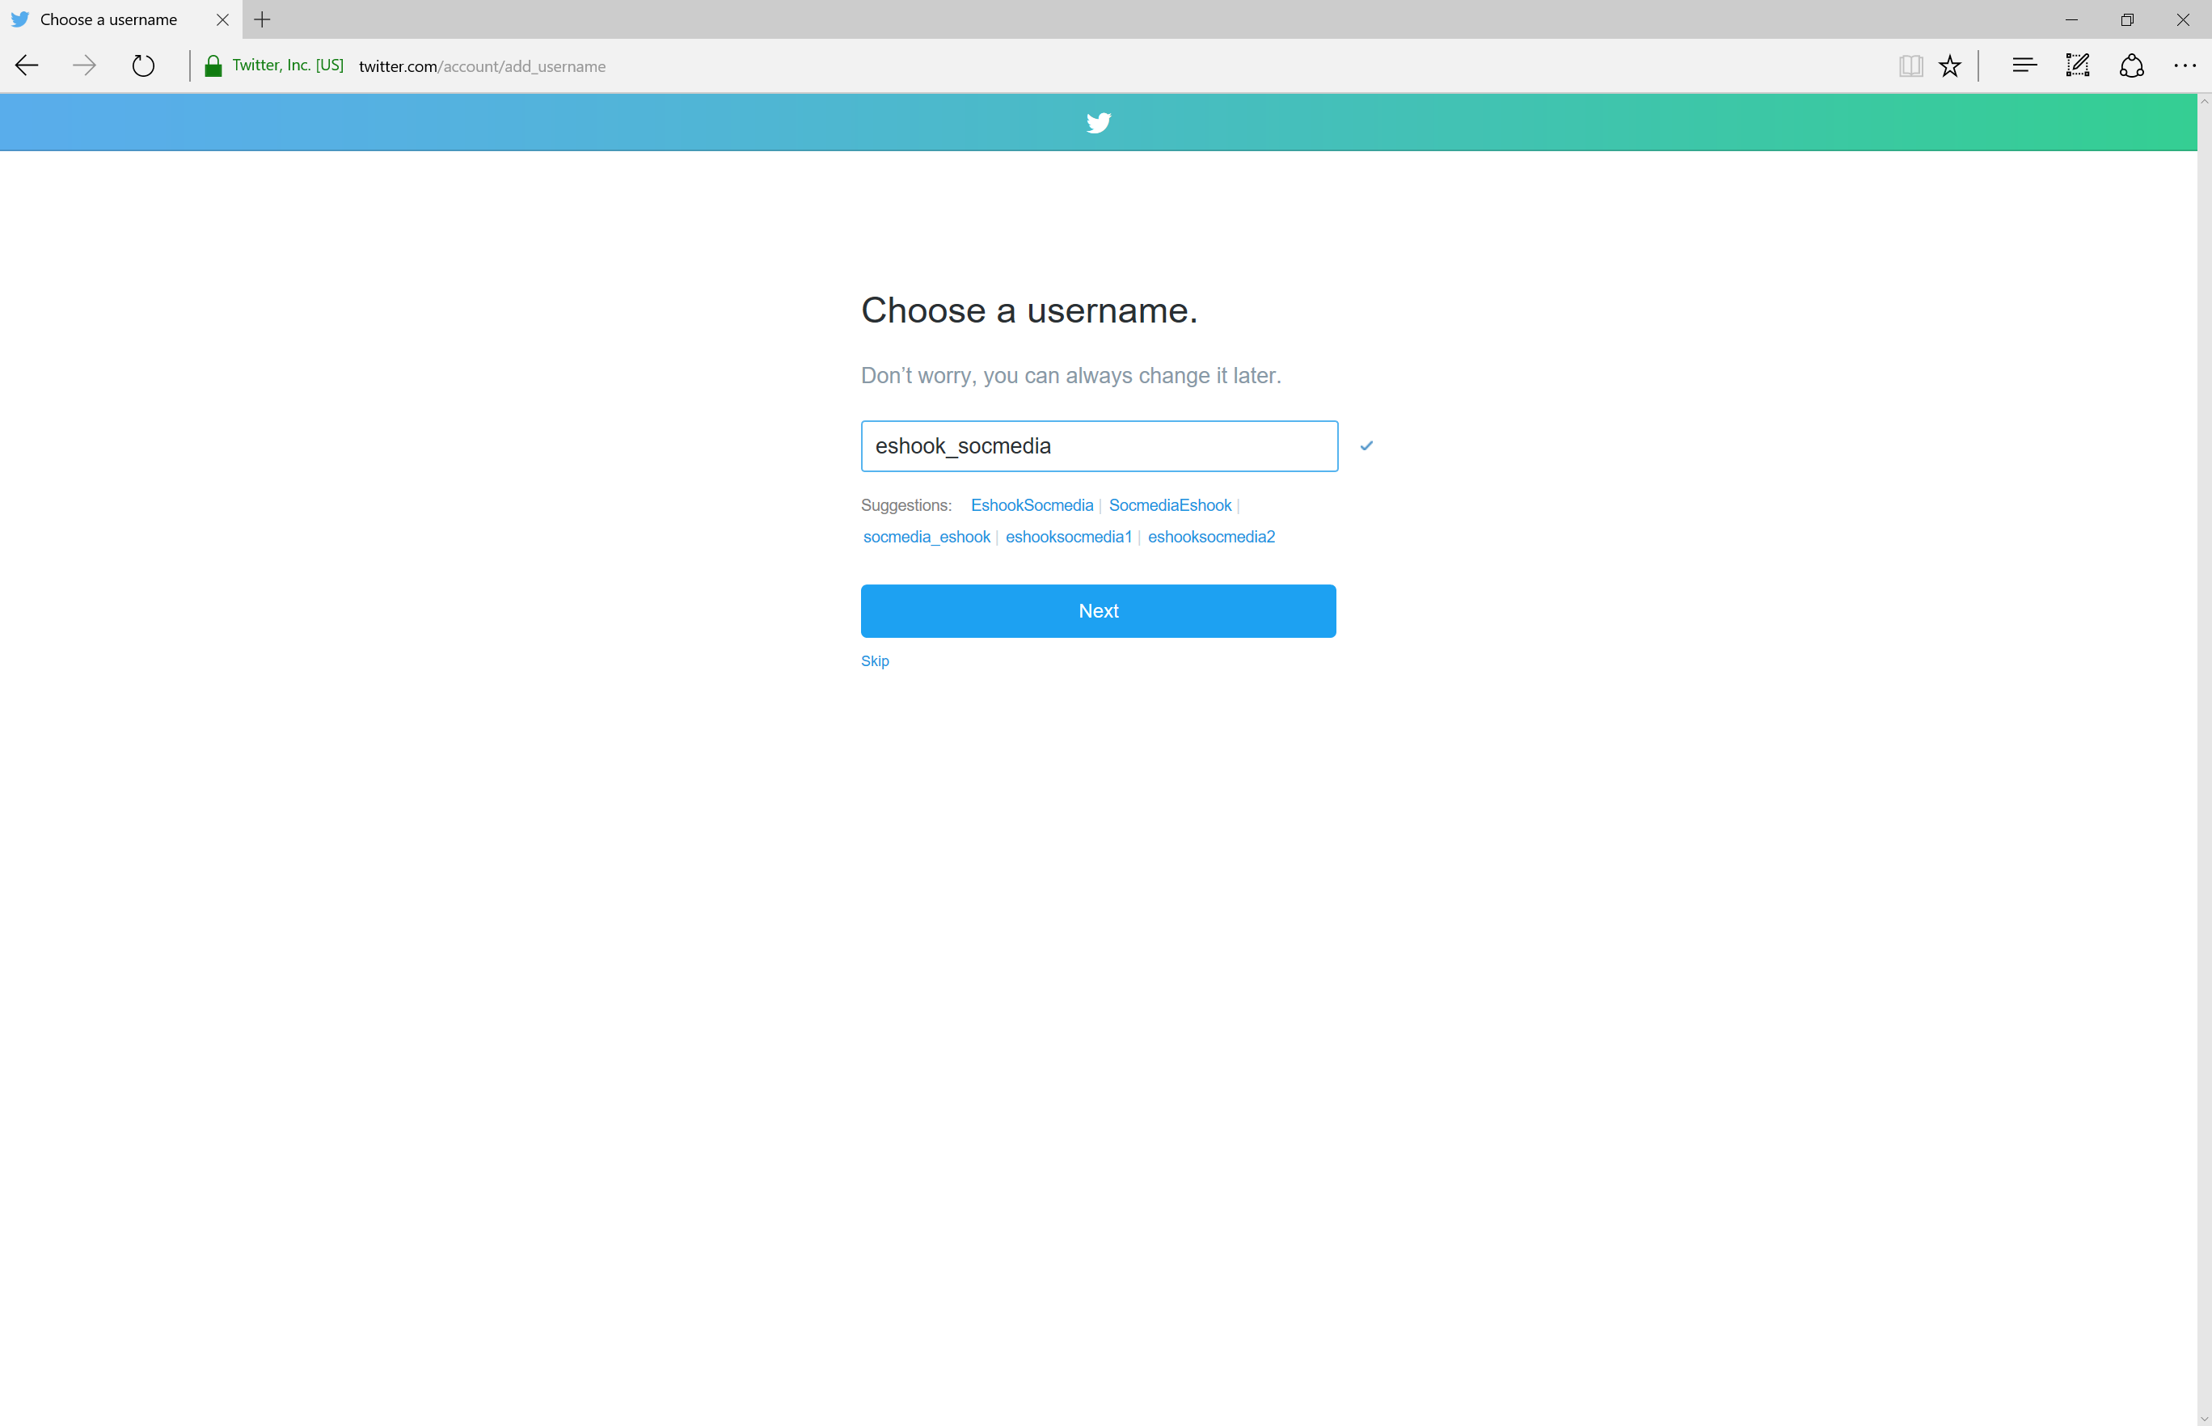

Skip interesting topics and finding friends steps by saying “Skip” or “No thanks”. Then you should see this:

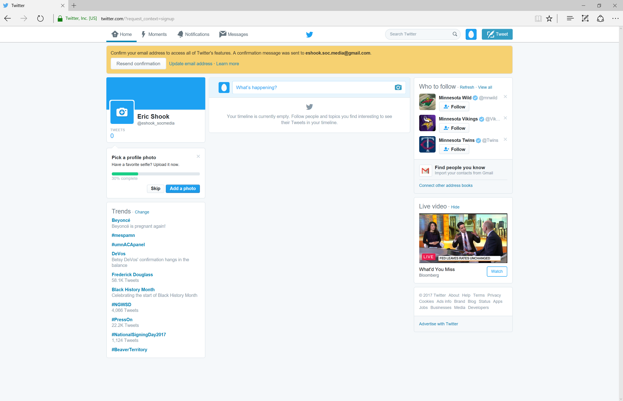

Now verify your account by checking your email. Click the “Confirm Now” button.   
You should then see a box stating: “Your account has been confirmed. Thanks!”

First, you can send your first tweet by clicking the “Tweet” button in the upper right corner.

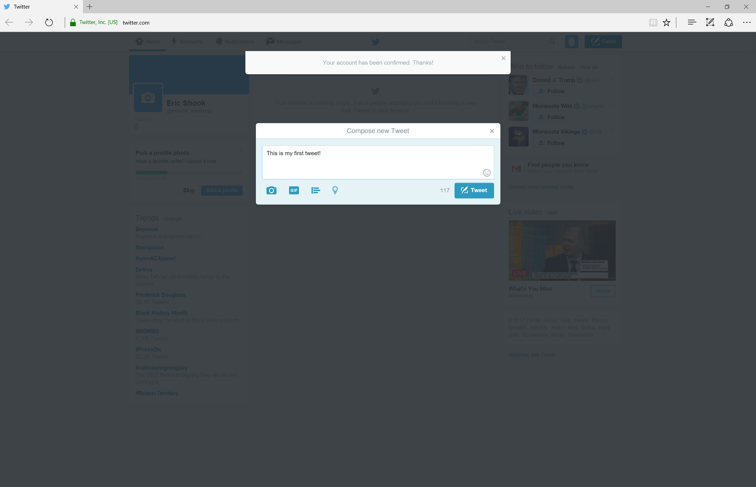

Notice how the location button is disabled.   
You have to ‘opt-in’ to enable locations for your tweet. Our first tweet will not have location information.

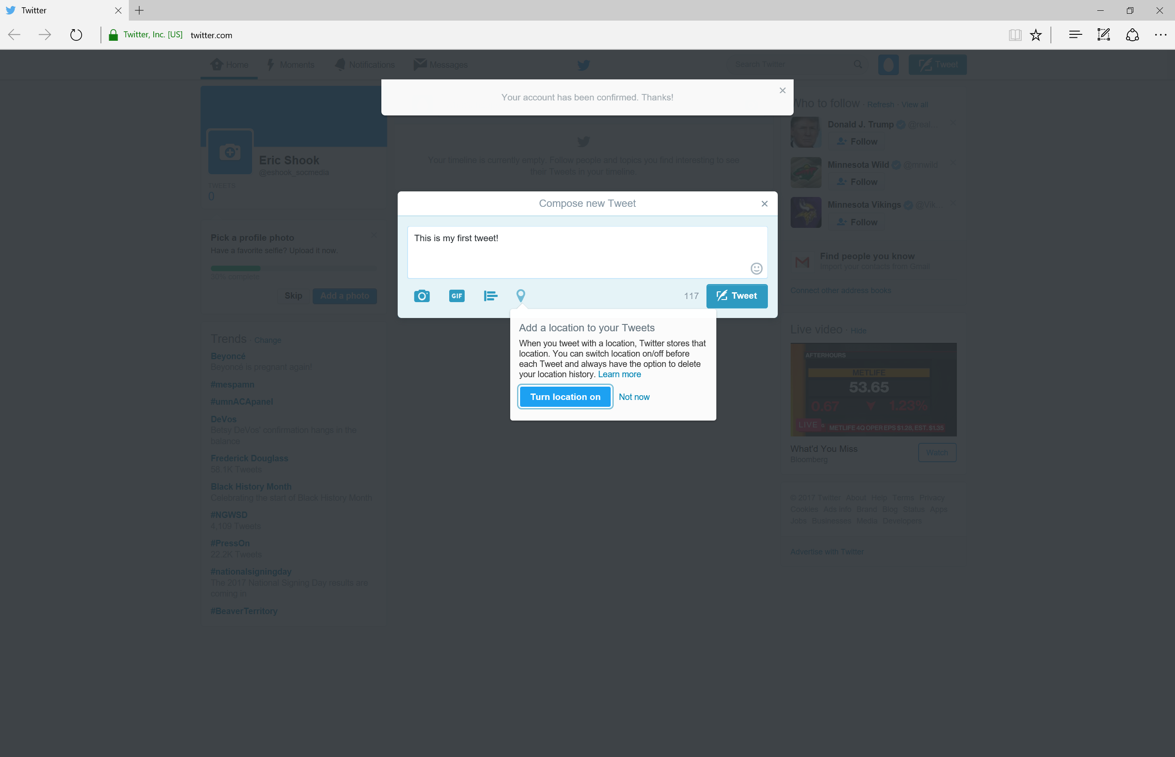

Next, we will send a tweet with geospatial information by clicking “Turn location on.” This is called a ‘geotagged’ tweet.

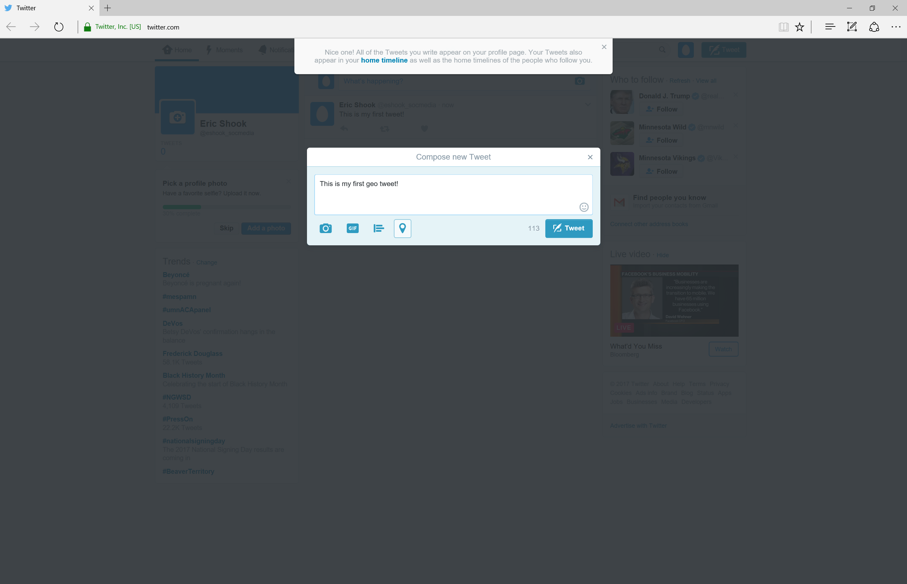

Look at our first two tweets!

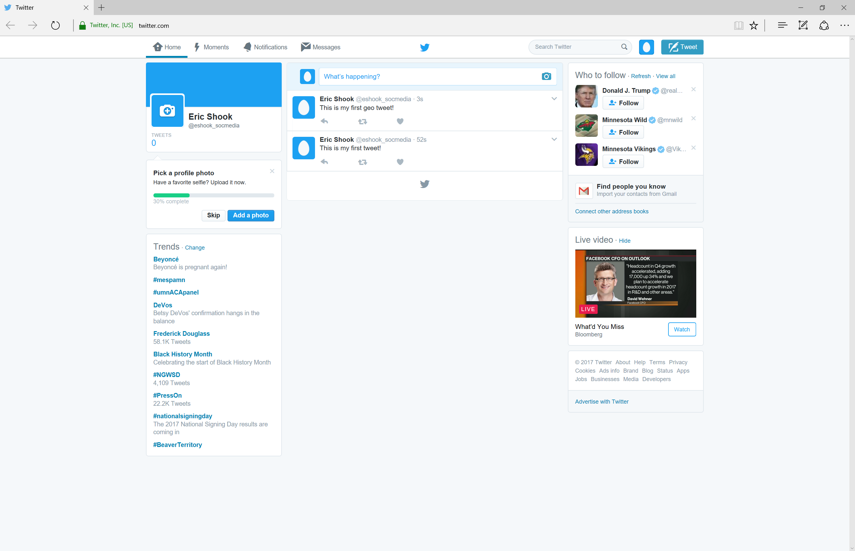

After sending our geotagged tweet we can click on it to look at our location.

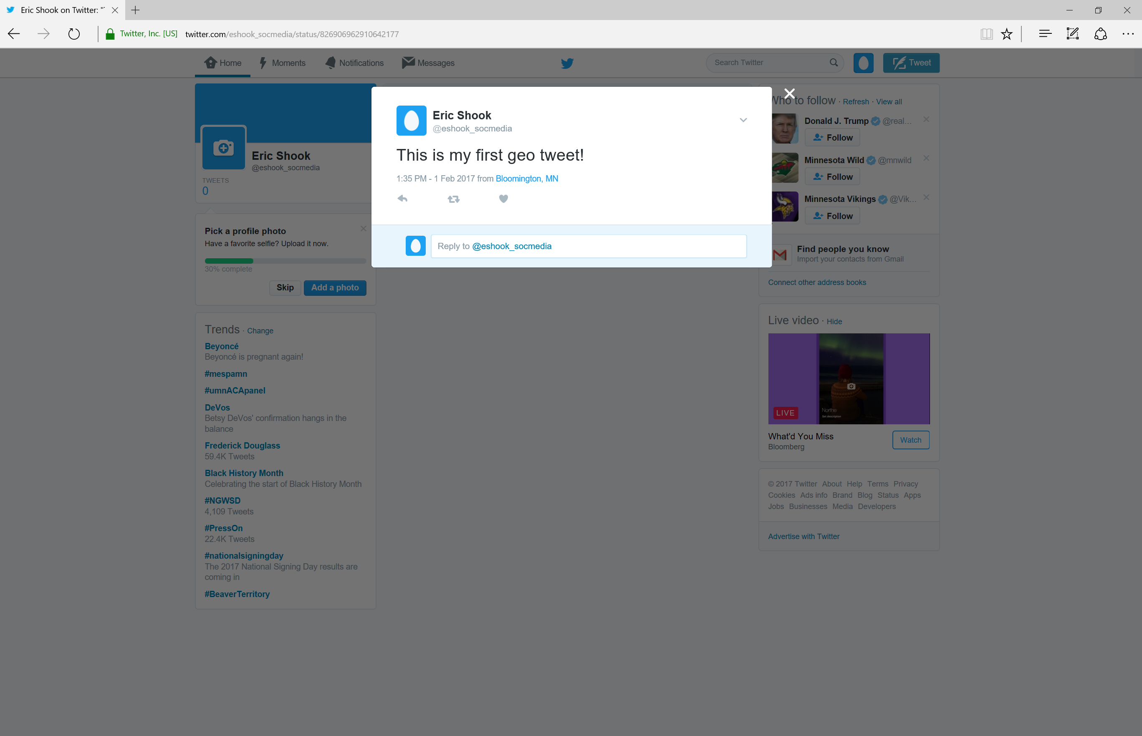

Searching for Tweets  
Now that we posted our first tweets we will start looking at what other folks are tweeting.   
  
We can use the “search” box. For example, we can search for tweets related to “water quality.”

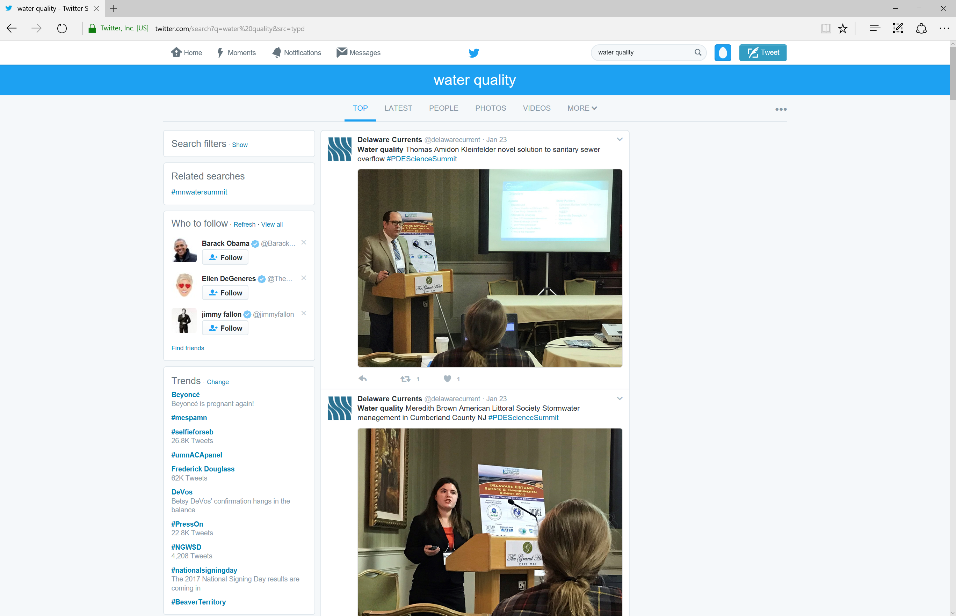

We can filter what we see using “Search Filters” on the left. By clicking on “Advanced Search.” We can search for questions about “water” and “quality” that are written in English.

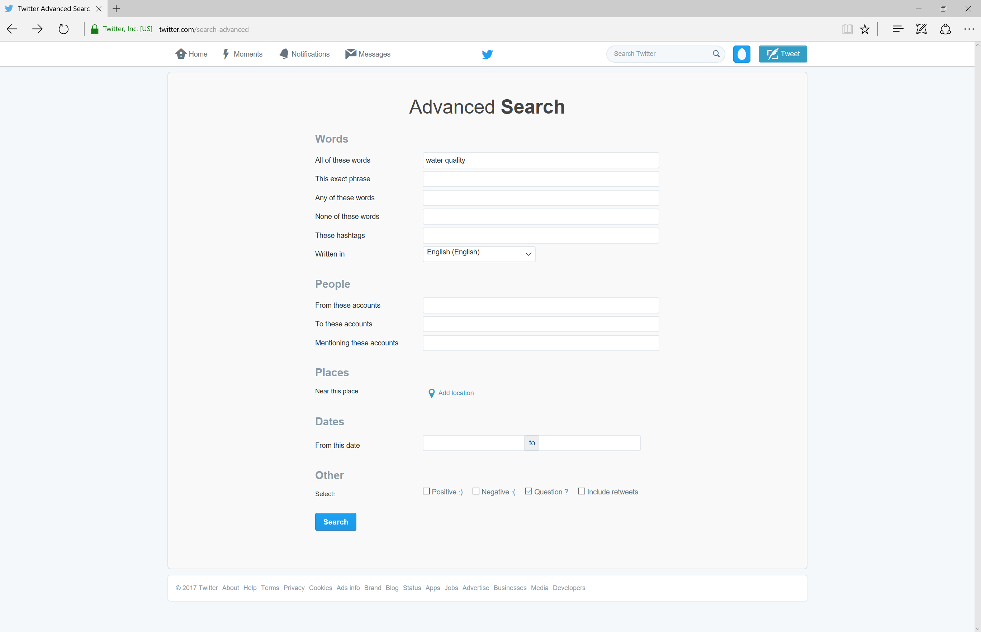

The results.

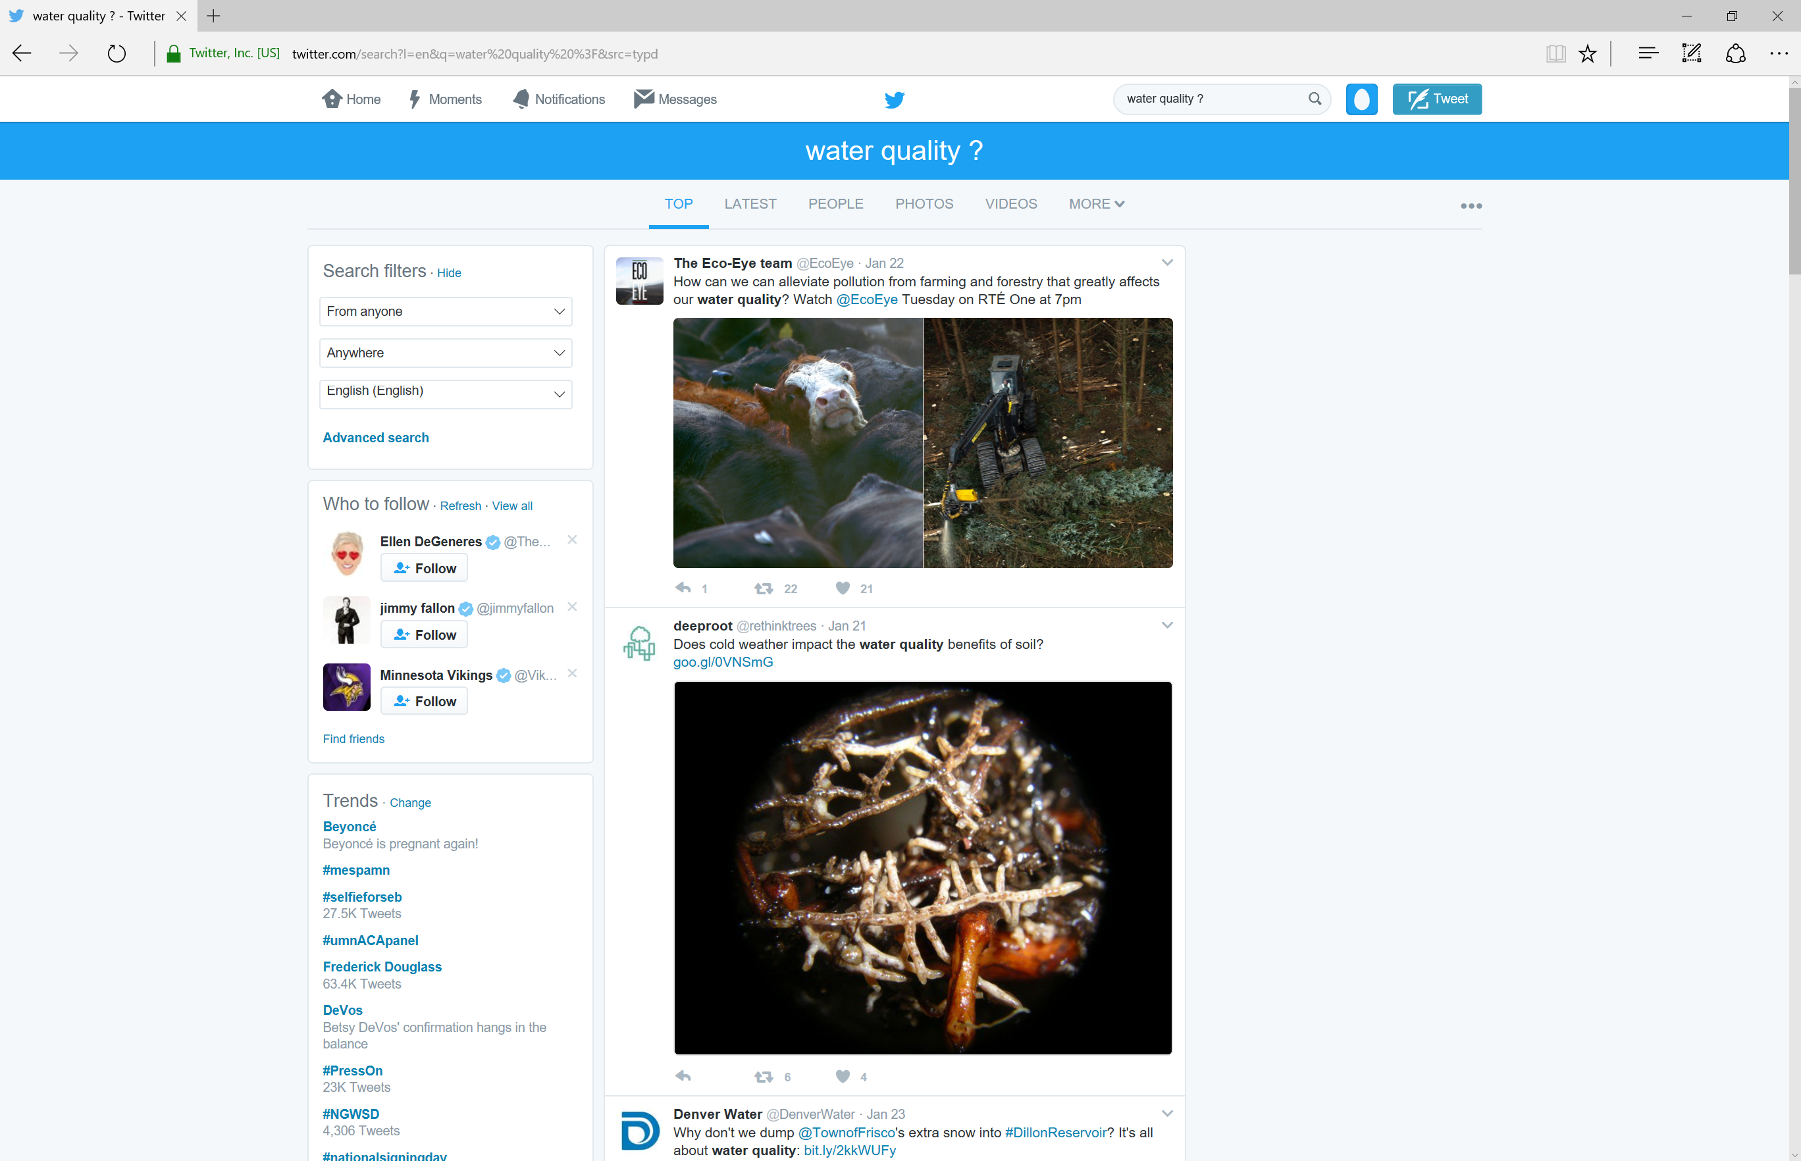

# Twitter Key Setup

Using the Twitter Search box you can filter based on language, location, keywords, users, time, among other aspects. However, after some initial exploration you will realize that this search mechanism becomes tedious and potentially error-prone for research purposes. So we will explore more advanced methods and techniques for capturing and analyzing social media data.

To do this we need to setup keys for authentication. We will be using the TwitterAPI package in this workshop. See the following page for additional information <http://geduldig.github.io/TwitterAPI/authentication.html>.

We can setup our keys using the Twitter Application Management site. We will setup an application and then generate our keys.  
  
Please go to:   
<http://apps.twitter.com>

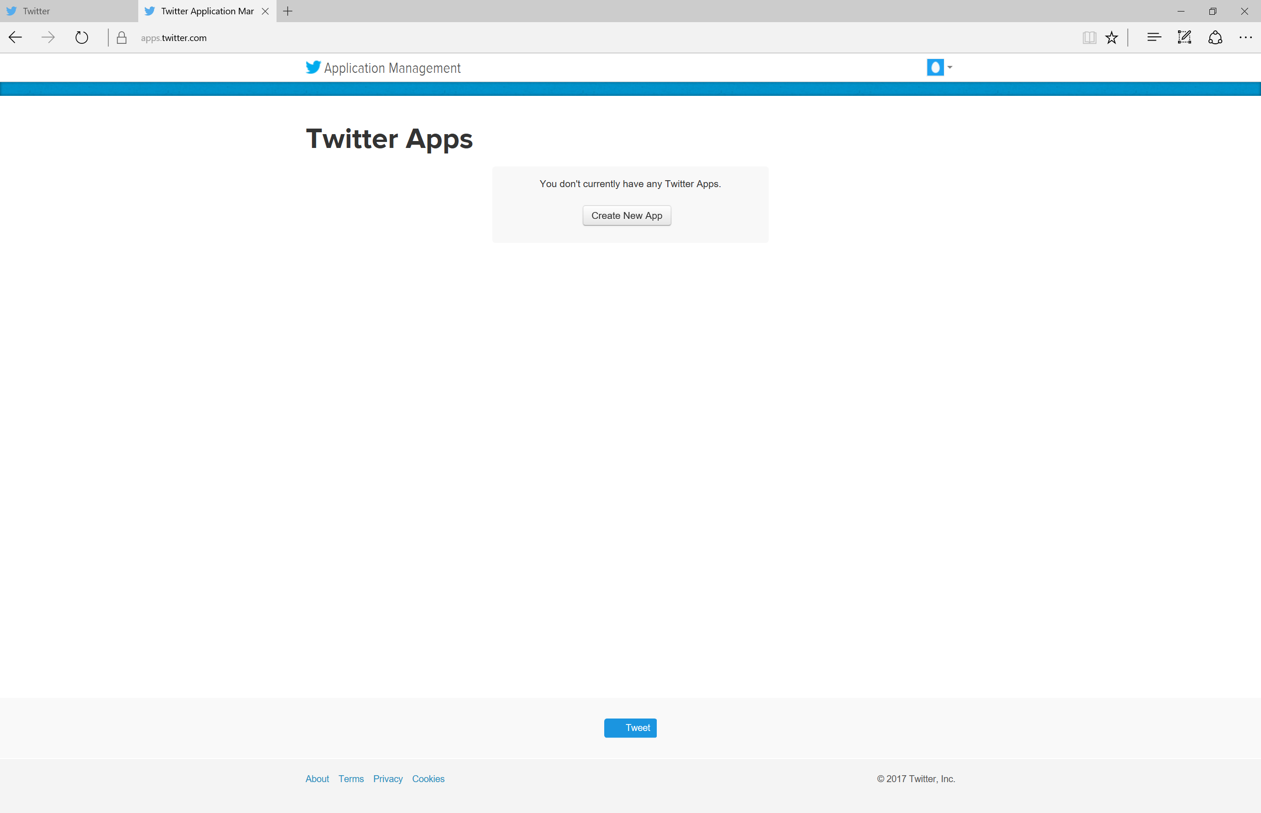

Click “Create New App”

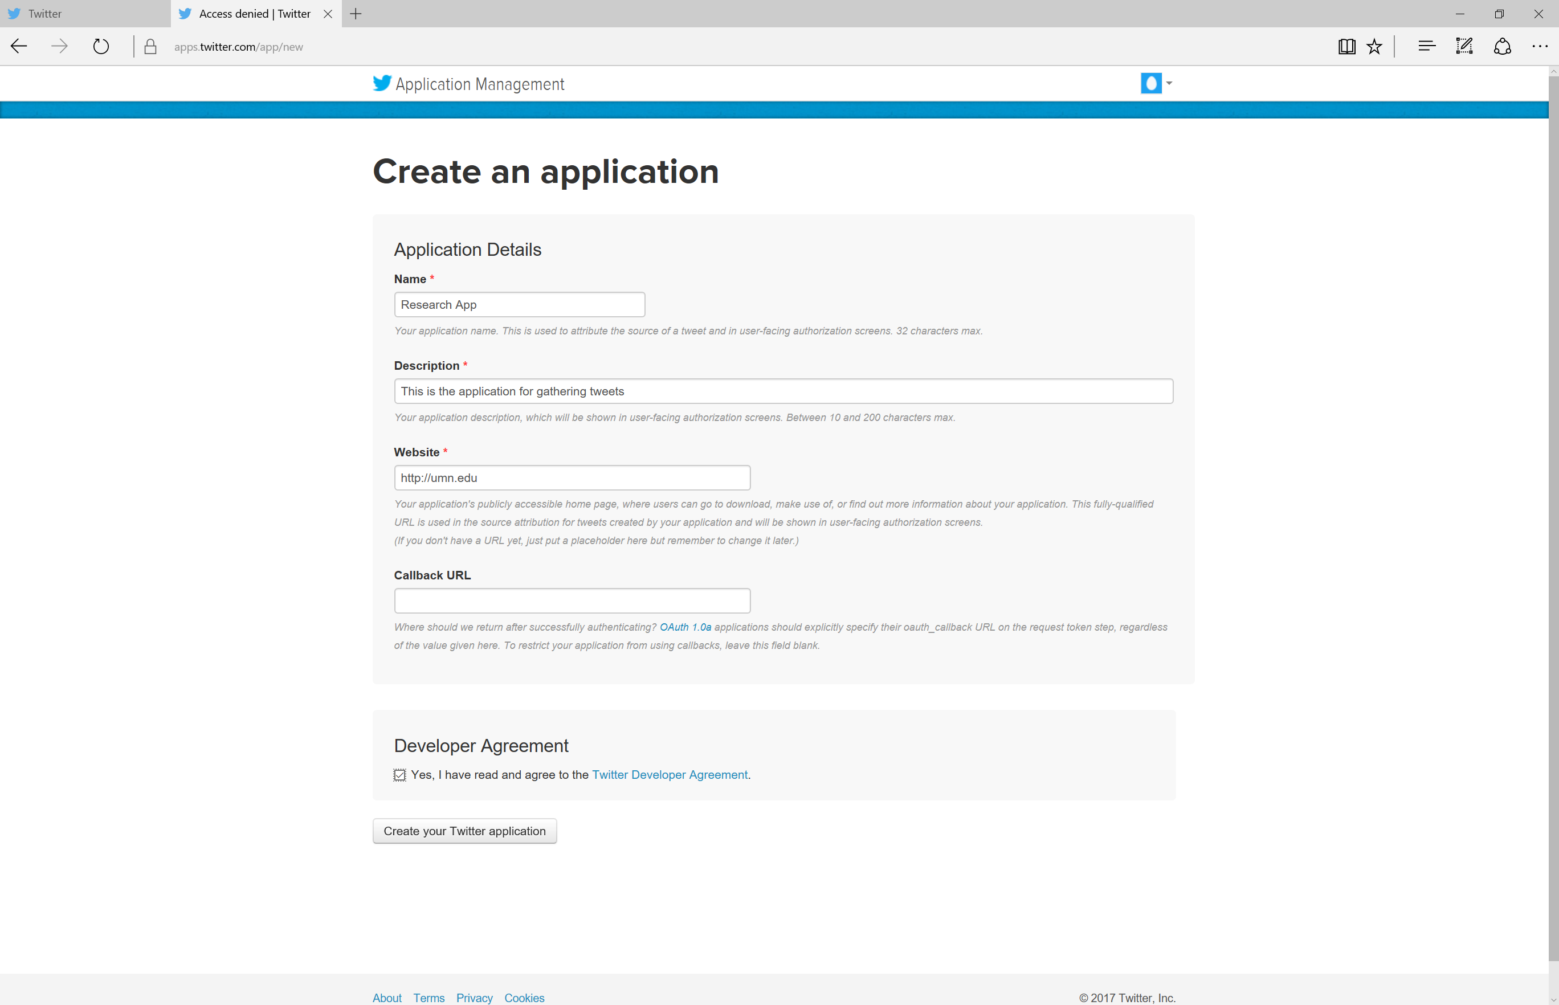

Fill in the relevant information and click “Create your Twitter application.   
**Important Note:** If you did not verify your account using your phone you will receive the following message.

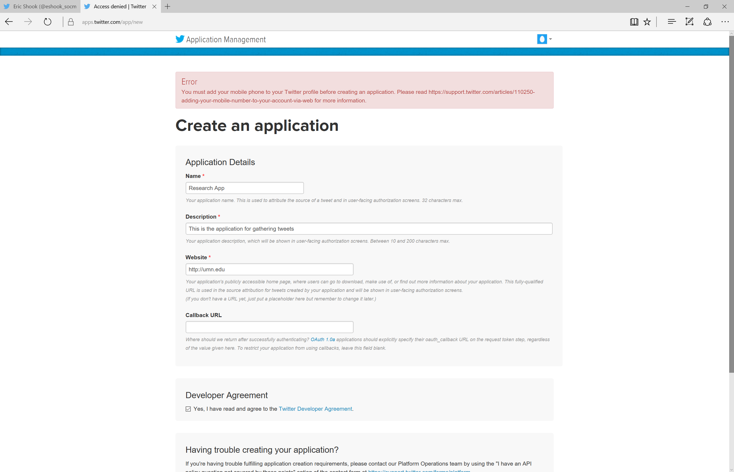

Follow the instructions to verify your account using a cellphone.   
You may also need to pick a new “Name.” Once complete, you should see a success screen similar to the following screen.

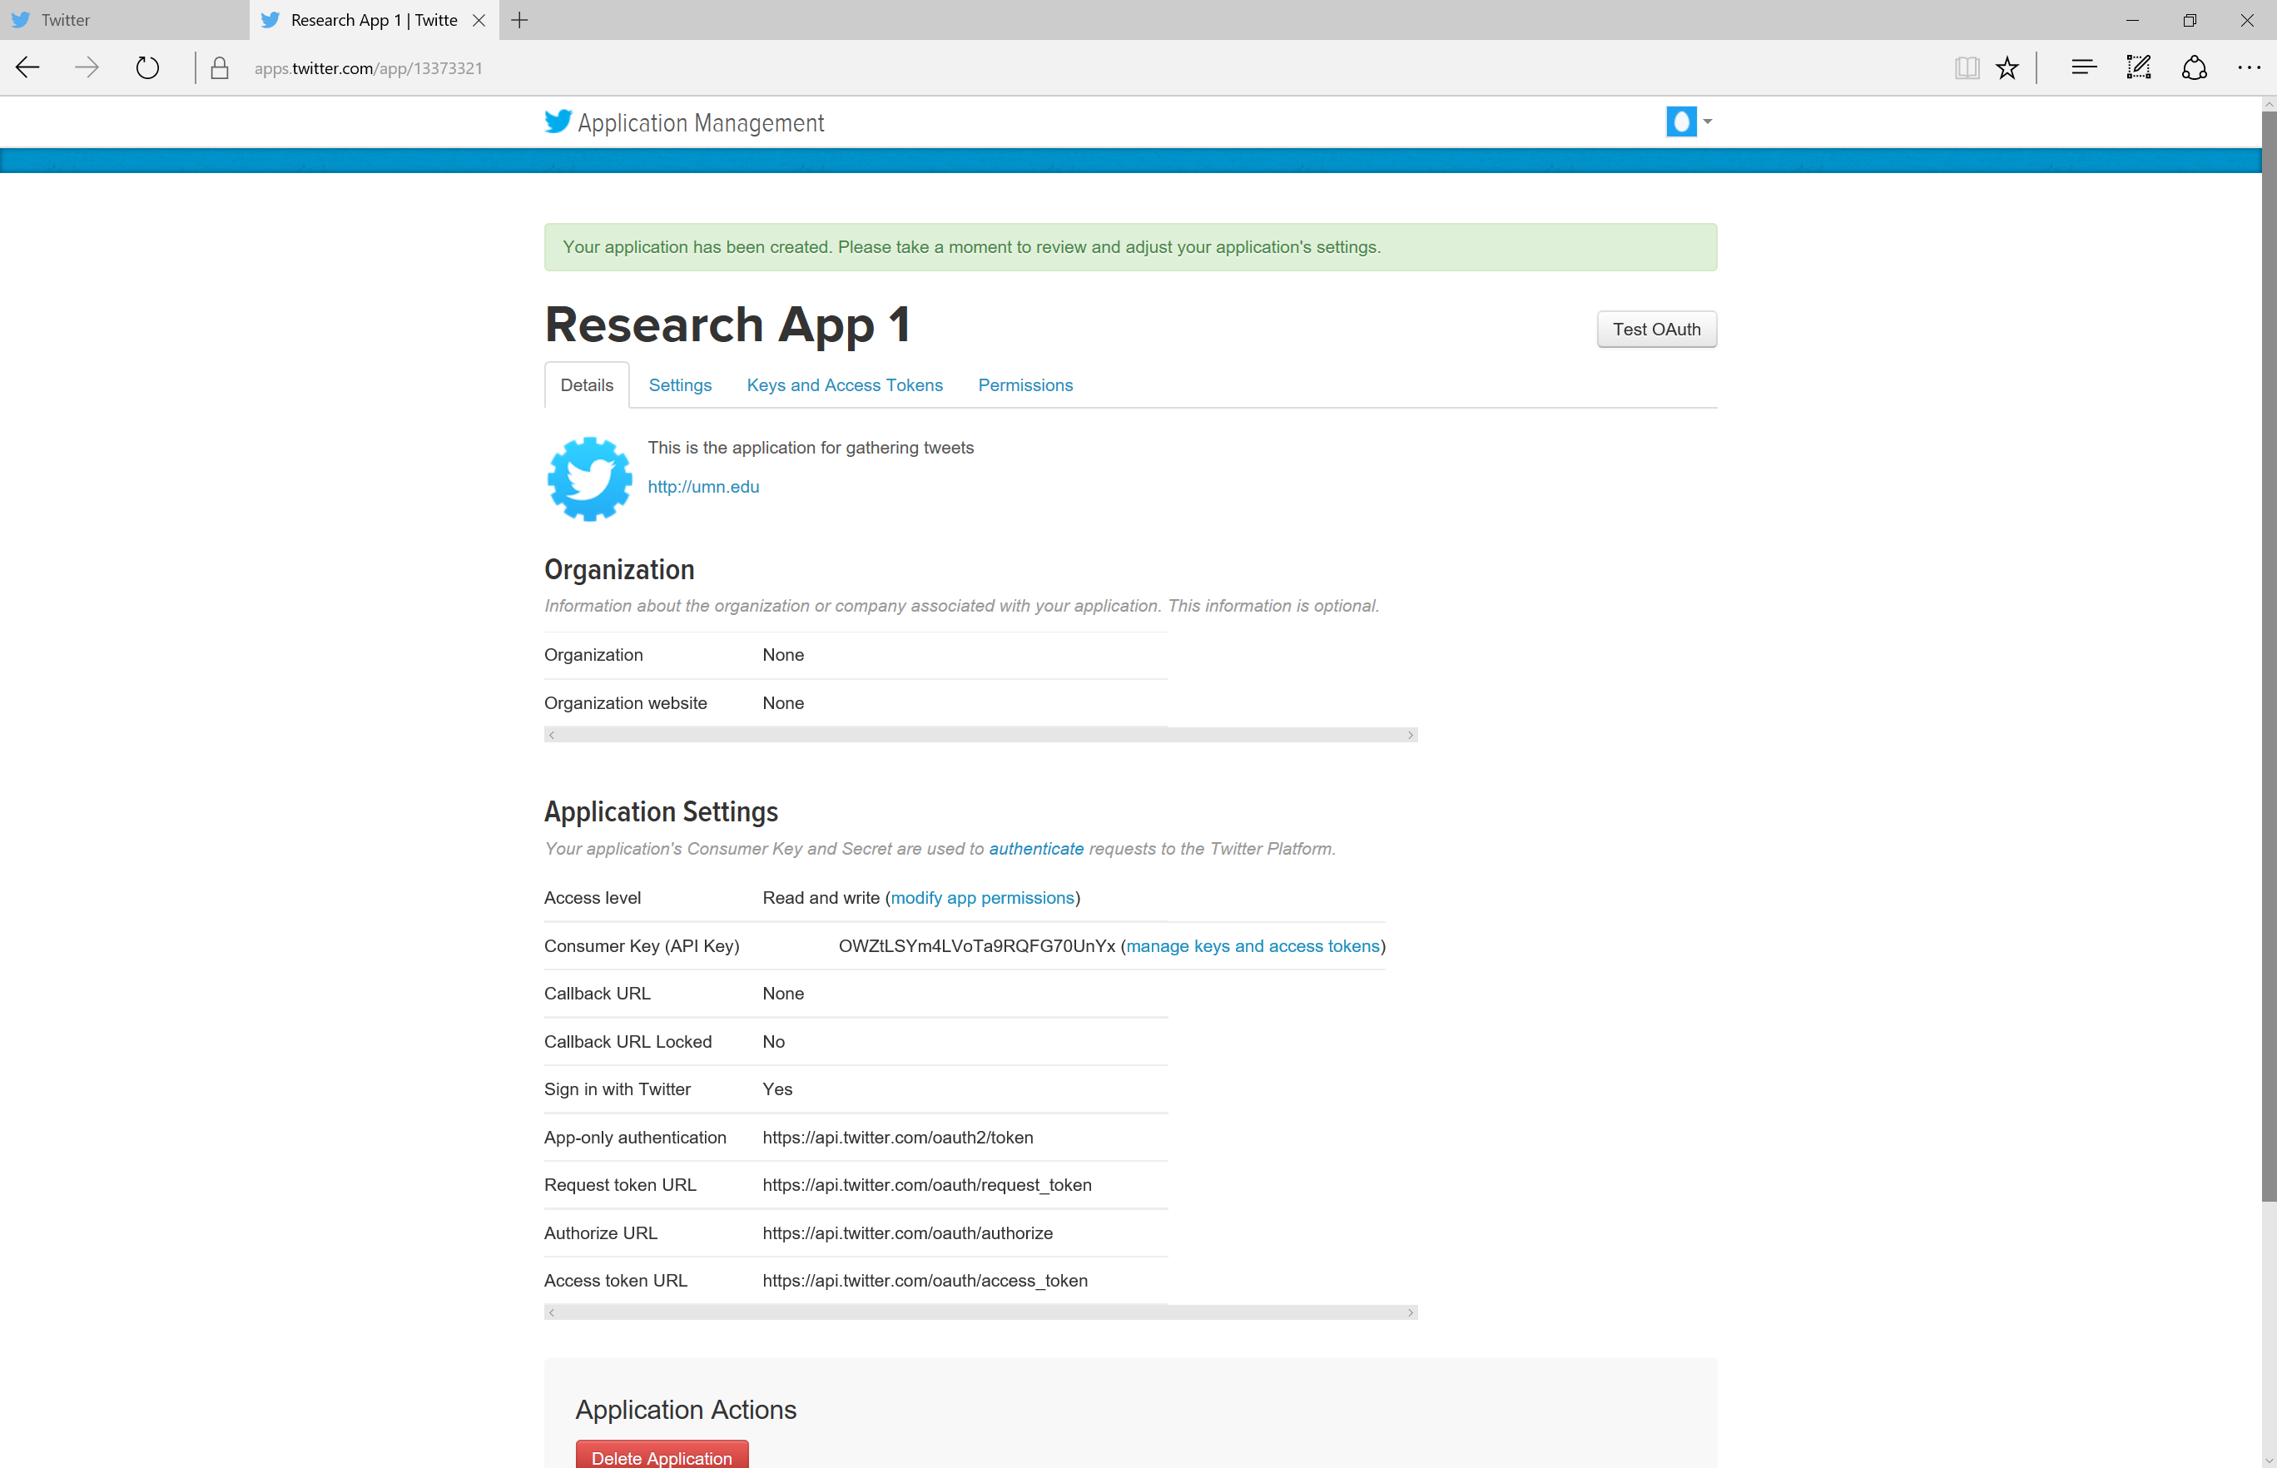

Next, click “Keys and Access Tokens”

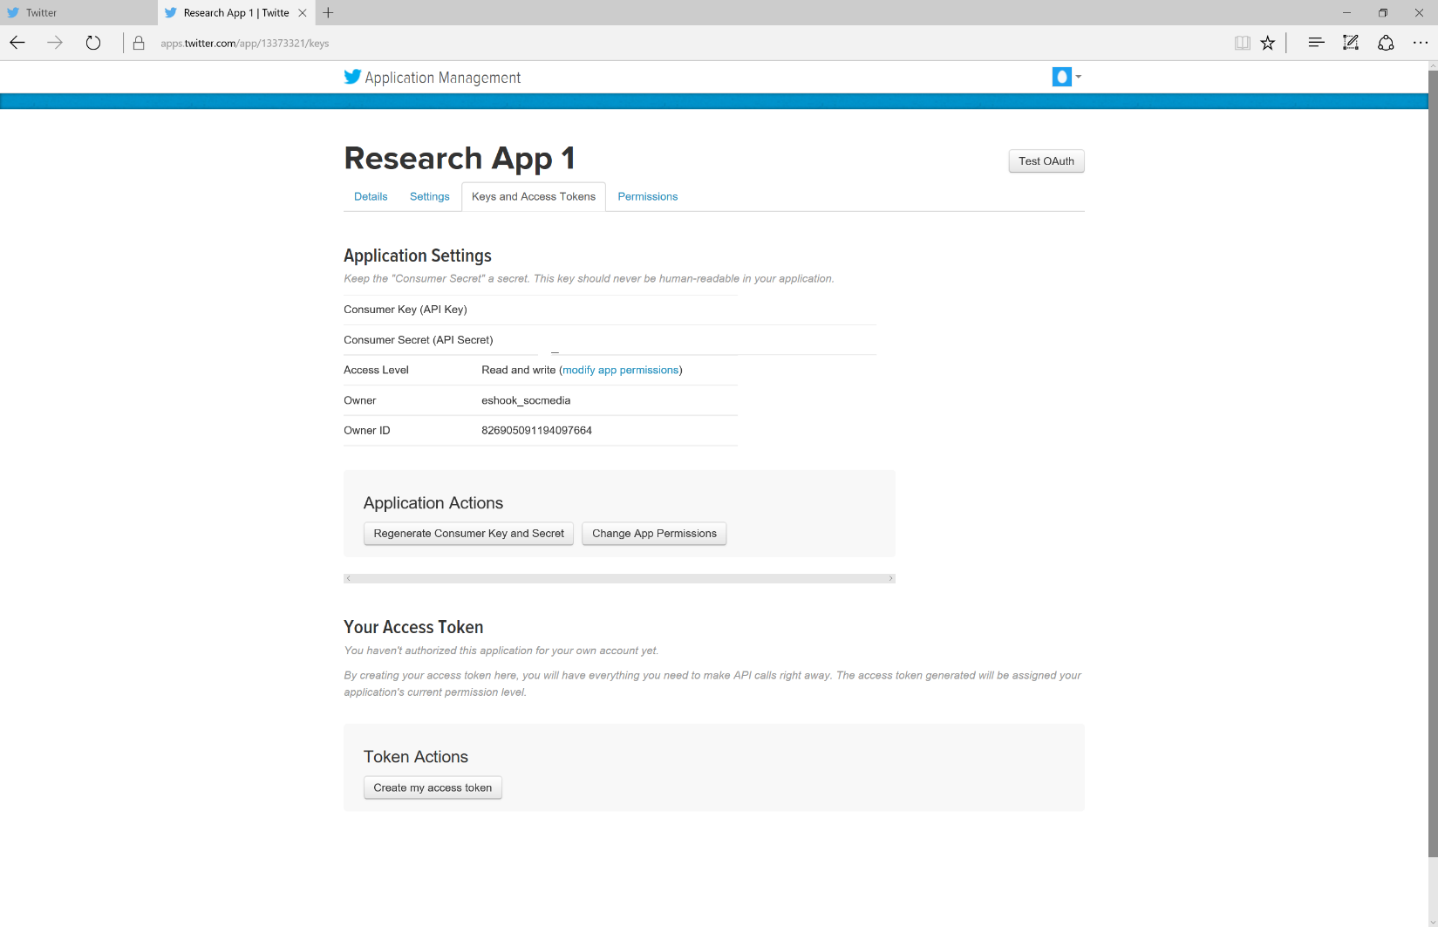

You need to generate your Access Token. Please click the “Create my access token” button at the bottom of the screen. The four critical keys and secrets are highlighted below. We will need these four strings of characters for our next step.

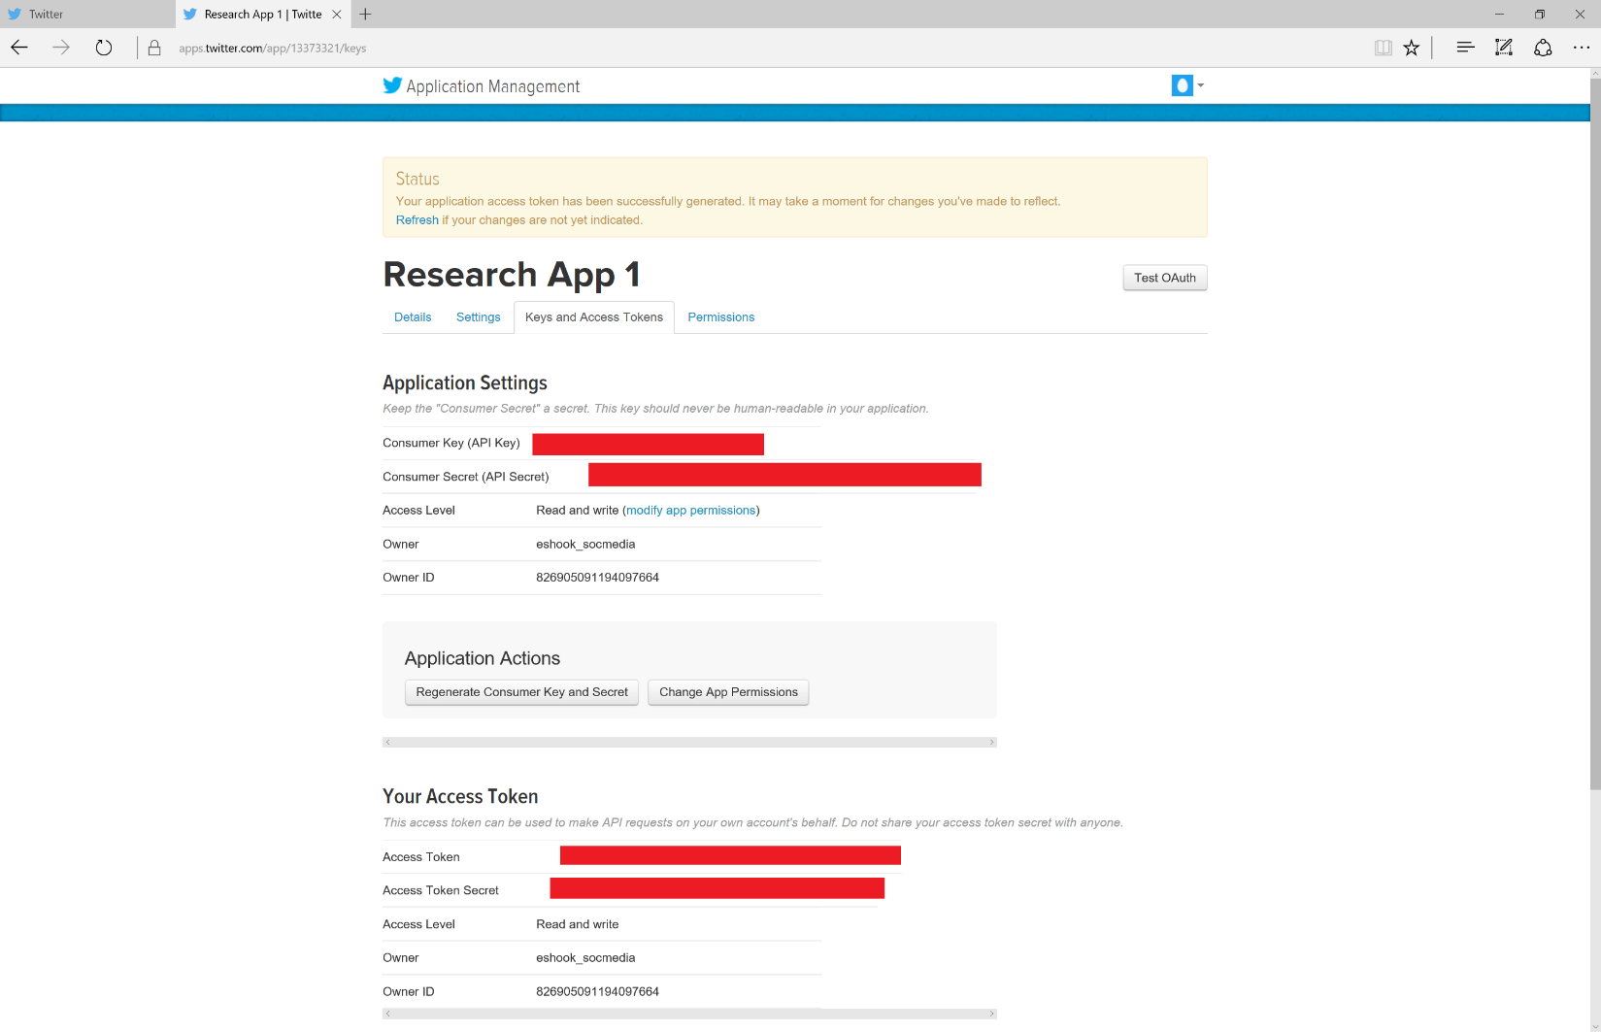

Congratulations!  
You now have a Twitter Account and an App that you can use to access Twitter data.

We will use TwitterAPI and Python today. If you have limited or no Python experience, not to worry.   
The code has already been written and will explained in the workshop.

**Important Note: Please keep the browser window open so you can copy and paste the keys and secrets you just created.**